**Combined RTF manual**

**General Steps:**

**Part 1: Prepare the DTA file by using %utility***(macro developed by Catlin Wei)****.***

**Part 2: Based on DTA file and TLF outputs, Use Azimuth to combine.**

**Part 1: Prepare DTA.txt for your study.**

* Step 1: Prepare your study status tracker and copy it to kennet folder ..\stats\macros\utlity. Make sure the contents of “Output Type”, “Output Identifier”, “Title” columns are well established in tracker.

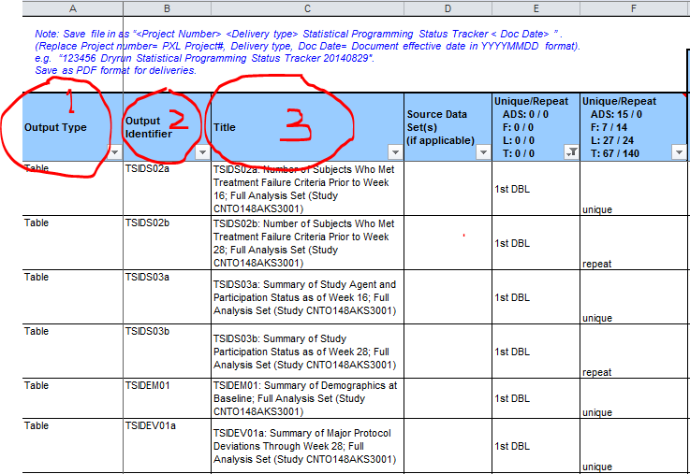

* Step 2: Copy the %utility macro from G:\Groups\STATISTICAL PROGRAMMING\DeptShare\21_Janssen\03_Macros for Janssen Standard TLFs _ Catlin Wei to study folder ..\JanssXXXXXX\stats\macros. And then adjust the macro parameters appropriately. *(Note: %utility macro is developed by Catlin, which can be used to create DTA.txt, TF.sasdata, and multirun.txt)*.

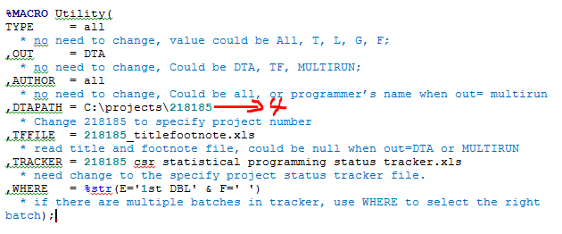

* Step 3: run %utility in kennet. DTA_data.txt will be created under …\stats\primary folder

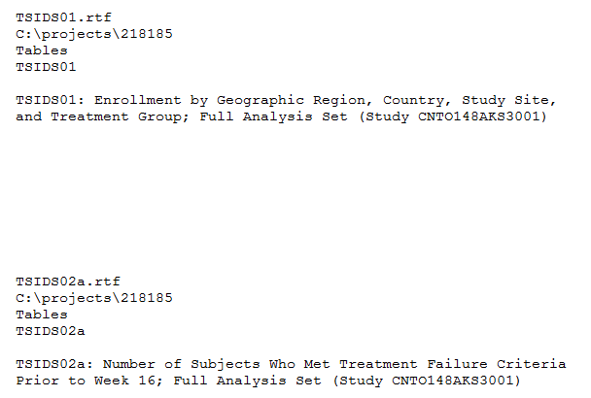

(Note: In this txt file, for each panel,

The first row and fourth row come from status tracker column 2.

The second row comes from %utility macro parameter &dtapath.

The third row comes from status column 1.

The Sixth row comes from status column 3.)

**Part 2: Based on DTA file and TLF outputs, Use Azimuth to combine. (***firstly, please ensure Azimuth has already been installed in your computer. If not, see below Azimuth Installation Guide:* [*http://statwiki.pxl.int/wiki/index.php/Azimuth_Installation_Guide*](http://statwiki.pxl.int/wiki/index.php/Azimuth_Installation_Guide)*)*

* Step 1: Create a local project folder as “C:\projects\218185”, replace 218185 with your project number, to be consistent with &dtapath(macro parameter in %utility), and then copy DTA_data.txt, all the TLFs rtf files into this path.
* Step 2: Prepare RTF template(Portrait and Landscape).

1. Select any one of Portrait TLF file and save it as doc file, remove all the contents, and rename it as rtfP.doc(could be any meaningful name). And select any one of Landscape TLFs rtf file, do the same step, and save as rtfL.doc. These two doc files will be used as template.

* Step 3: Create a new doc file under the same folder and open, then click Az icon:

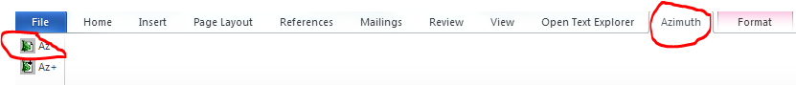

* Step 4: Click below icon and then adjust Azimuth default setting as following

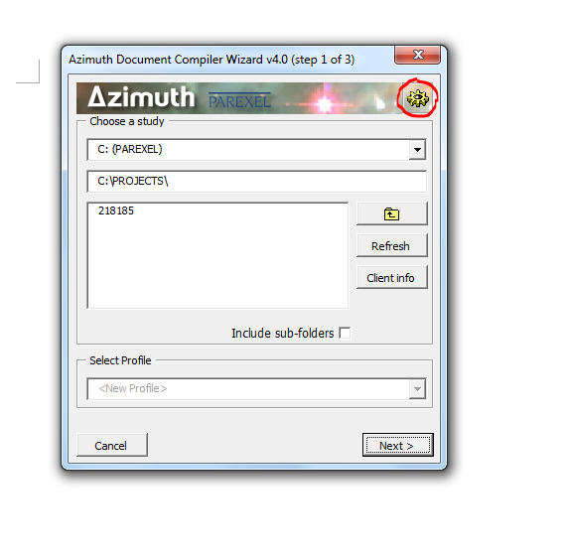

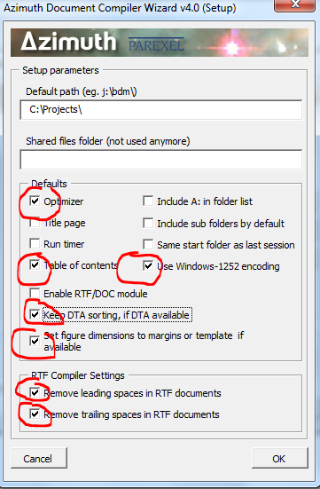

* Step 5: Click below icon and set up client info and doc format.

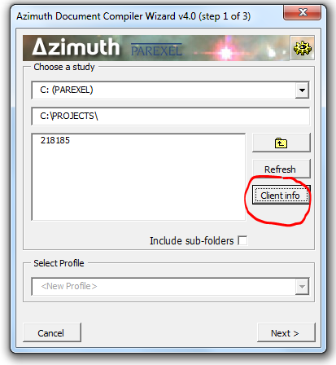

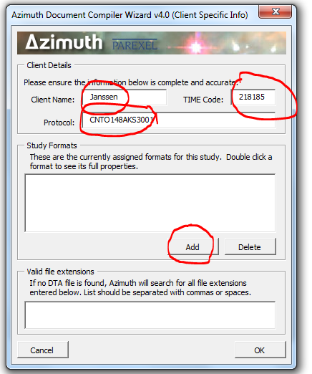

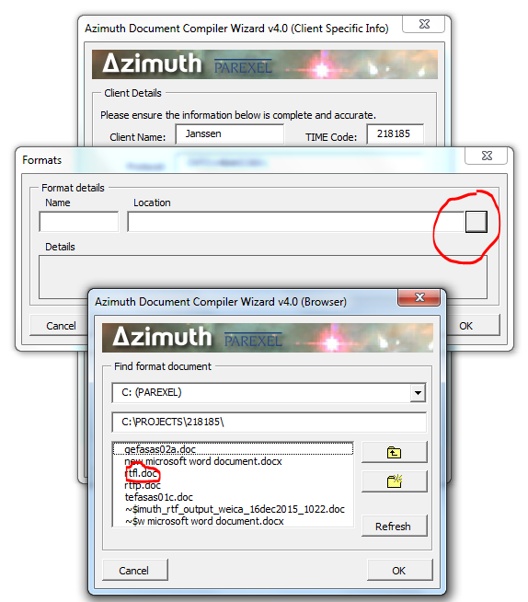

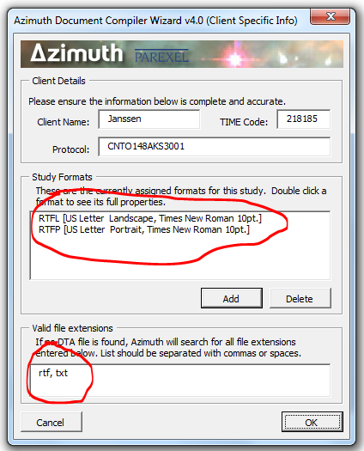

(After following steps, an AzimuthData folder containing azimuth_clientinfo2.txt file will be automatically created under “C:\projects”. And the file contains below information:

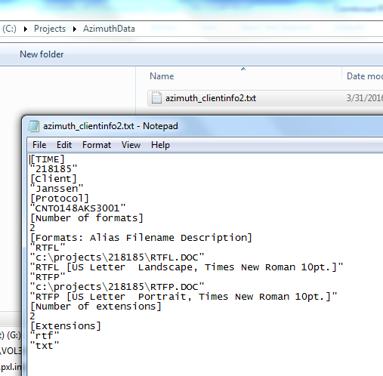

* Step 6: double click the “project number” and follow steps

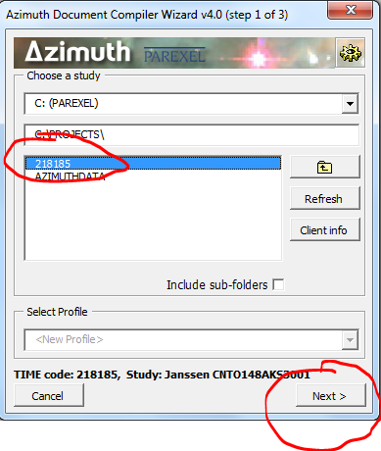

* Step 6: choose all files and add all of them.

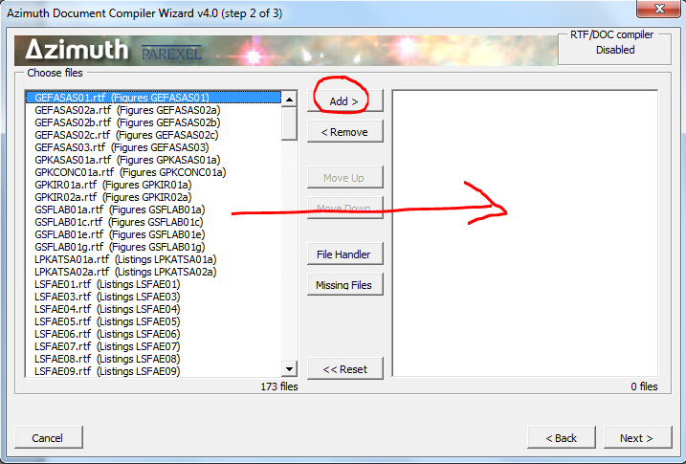

* Step 7: assign the RTF format for each TLFs as below, and adjust the general settings

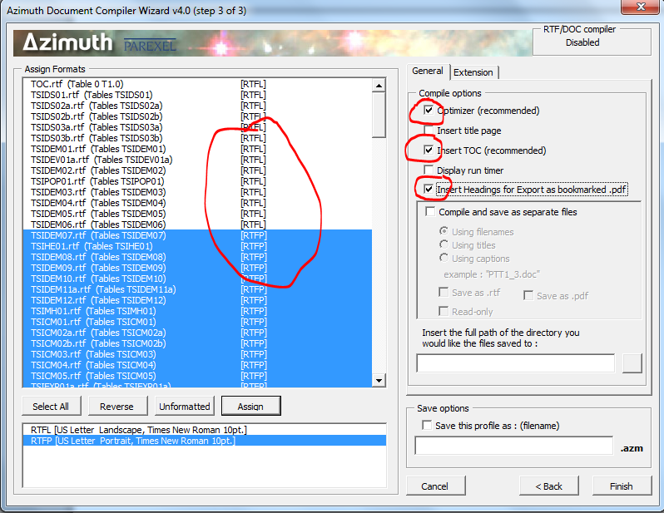

* Step 8: adjust extension settings as below and go next.

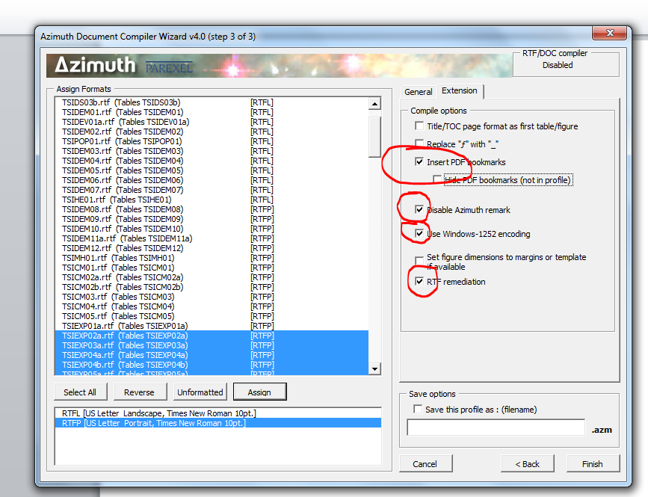

* Step 9: click finish bottom. The combined RTF will be created in several mins. Before convert the doc to pdf, delete the red highlighted part.

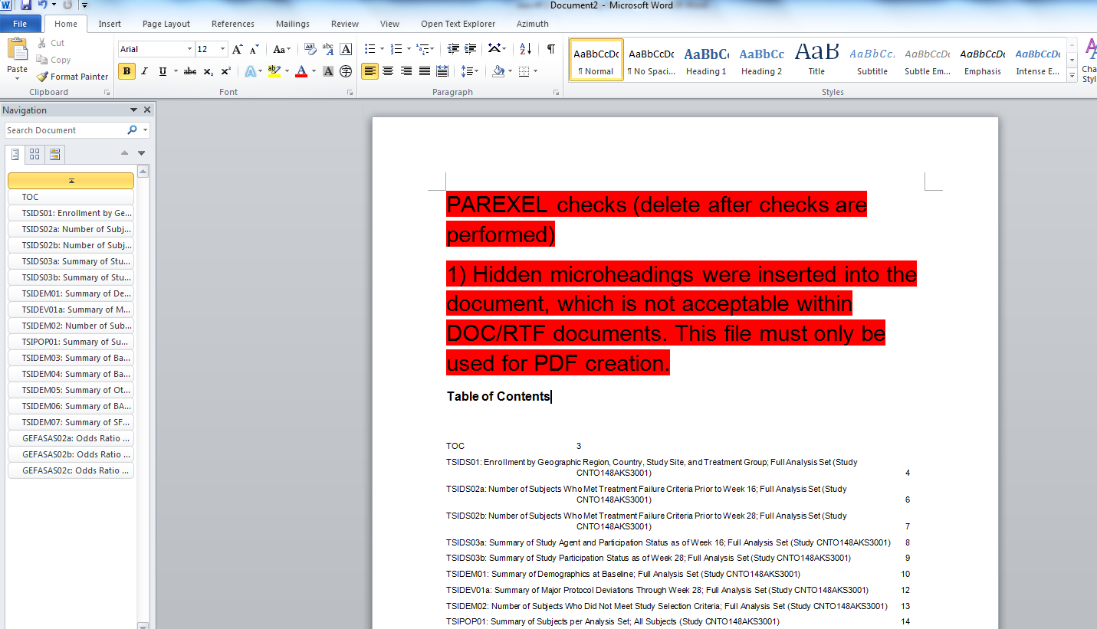

* Step 10: Save file as pdf with below options.

